Running the Haubensak Lab Seurat/RStudio Container

General info
This guide explains how to install Docker and run the Haubensak Lab RStudio/Seurat environment:
haubensaklab/seurat-rstudio:latest
The container makes RStudio Server available in a web browser. It will publish container port 8787 to your computer and mount a local Data folder into the container at:
/home/rstudio/data
A bind mount lets the container access files stored in a specified folder on your laptop, while the files remain on the laptop itself.^{[1][2]}
Important: Use the commands exactly as shown, but replace the example folder paths with the actual location of your local Data folder.

Windows Installation
1. Install Docker Desktop
- Download Docker Desktop for Windows from the official Docker website:
  - Docker Desktop download: https://www.docker.com/products/docker-desktop/
  - Official installation instructions: https://docs.docker.com/desktop/setup/install/windows-install/
  - Docker’s introductory video/tutorial material: https://www.docker.com/101-tutorial/
- Run Docker Desktop Installer.exe.
- During installation, select the WSL 2 backend when prompted, unless your local IT configuration requires Hyper-V instead. Docker’s official guide covers the system requirements and WSL 2 setup options.^{[3]}
- Start Docker Desktop and wait until it reports that the Docker Engine is running.
2. Create a local Data folder
Create a folder called Data on a drive with sufficient free space, for example:
D:\Data
Place the Github Lesson1-5 data, analysis scripts, and exported results in this folder. It will be visible inside the container as /home/rstudio/data.
3. Download and run the image
Step 1
- Option 1 Docker Desktop
Open Docker Desktop and
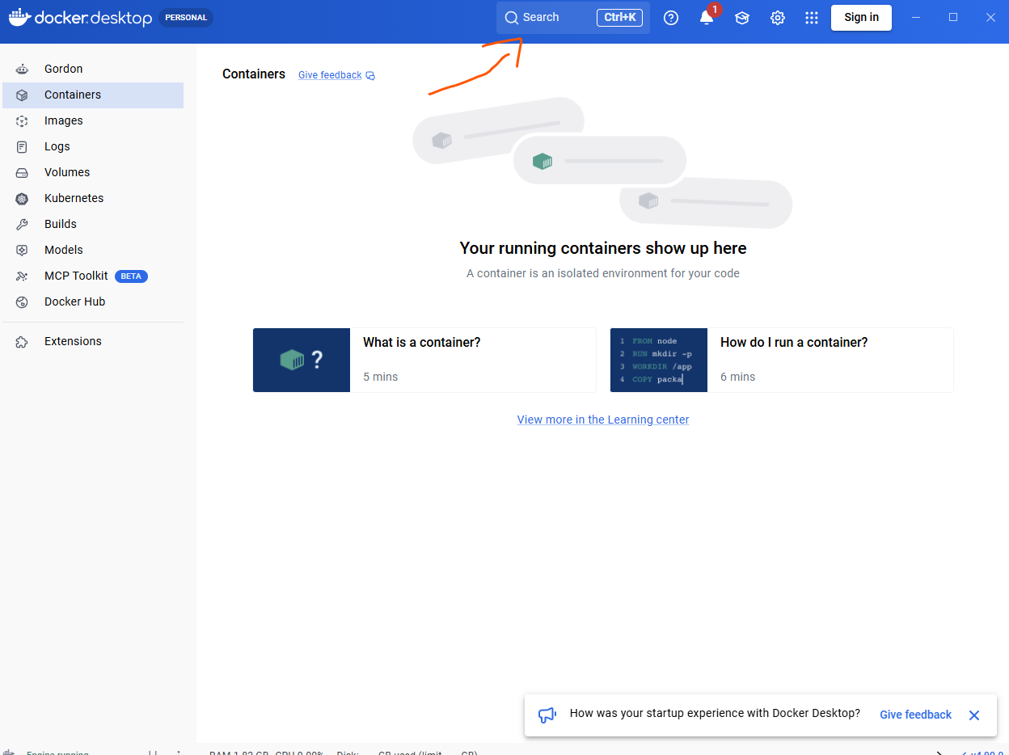
download the haubensaklab/seurat-rstudio:latest image by typing in the search bar (top, middle) and clicking pull.
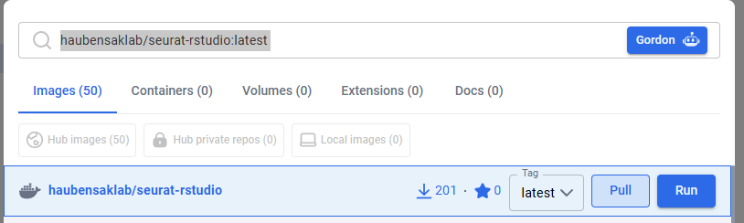
Once done, go to the Images tab (on the left side)
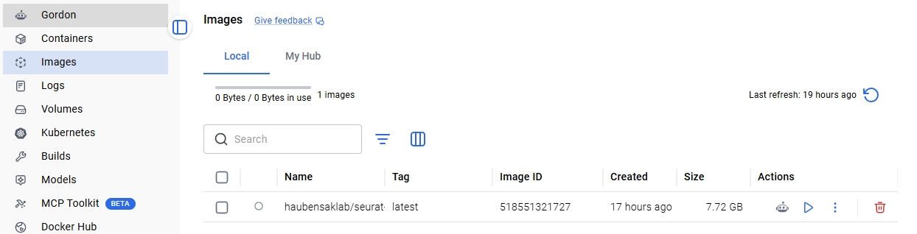
and click Run on the downloaded image, and type the appropriate things into the window (click on the arrow in Optional Settings):
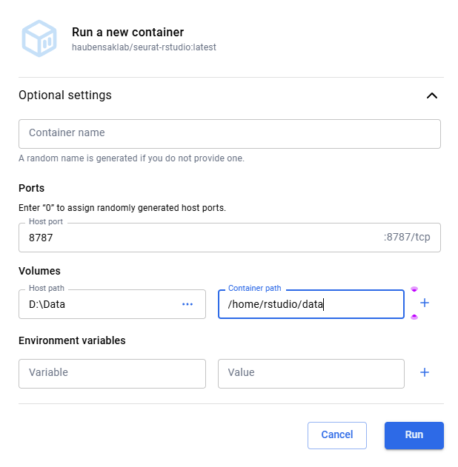

- Option 2 Console
Open PowerShell and run:
docker pull haubensaklab/seurat-rstudio:latest
Then start the container:
docker run -d --name seurat-rstudio -p 8787:8787 -v "D:\Data:/home/rstudio/data" haubensaklab/seurat-rstudio:latest
The -p 8787:8787 option maps RStudio Server’s container port 8787 to port 8787 on your laptop; Docker uses the -p HOST_PORT:CONTAINER_PORT form for port publishing.^{[4]}
If Docker Desktop cannot access D:\Data, check Docker Desktop settings and allow file sharing/access to the relevant drive or folder.

Linux Installation
1. Install Docker Engine
For most Linux systems, install Docker Engine rather than Docker Desktop. The official Docker installation overview provides distribution-specific instructions.^{[5]}
- Docker Engine installation overview: https://docs.docker.com/engine/install/
- Ubuntu instructions: https://docs.docker.com/engine/install/ubuntu/
- Debian instructions: https://docs.docker.com/engine/install/debian/
- Fedora instructions: https://docs.docker.com/engine/install/fedora/
- Docker Desktop for Linux, if preferred: https://docs.docker.com/desktop/setup/install/linux/^{[6]}
After installation, verify Docker:
docker --version
If Docker commands require sudo, either prepend sudo to the commands below or configure non-root Docker access according to your institution’s IT and security policies.
2. Create a local Data folder
For example, create a Data folder in your home directory:
mkdir -p ~/Data
The corresponding full path is usually:
/home/YOUR-USERNAME/Data
3. Download and run the image
Download the image:
docker pull haubensaklab/seurat-rstudio:latest
Run the container, mounting your local Data directory:
docker run -d --name seurat-rstudio -p 8787:8787 -v "$HOME/Data:/home/rstudio/data" haubensaklab/seurat-rstudio:latest

macOS install
1. Install Docker Desktop
- Download Docker Desktop for macOS:
  - Docker Desktop download: https://www.docker.com/products/docker-desktop/
  - Official macOS installation guide: https://docs.docker.com/desktop/setup/install/mac-install/
  - Docker tutorial material: https://www.docker.com/101-tutorial/
- Select the installer appropriate to your Mac:
  - Apple Silicon for M-series Macs.
  - Intel for Intel-based Macs.
- Open the downloaded Docker.dmg, drag Docker into the Applications folder, then start Docker Desktop from Applications. Docker’s macOS documentation describes these installation steps and first-run configuration.^{[7]}
- Wait until Docker Desktop indicates that Docker is running.
- Open Terminal and verify the installation:
docker --version
2. Create a local Data folder
Create a folder in your home directory:
mkdir -p ~/Data
This is normally located at:
/Users/YOUR-USERNAME/Data
3. Download and run the image
In Terminal, download the image:
docker pull haubensaklab/seurat-rstudio:latest
Run it with port 8787 published and your local Data folder mounted:
docker run -d --name seurat-rstudio -p 8787:8787 -v "$HOME/Data:/home/rstudio/data" haubensaklab/seurat-rstudio:latest
Docker Desktop may ask for permission to access local folders; grant access to the chosen Data folder if prompted.

Opening RStudio Server
Open RStudio Server in a browser: http://localhost:8787
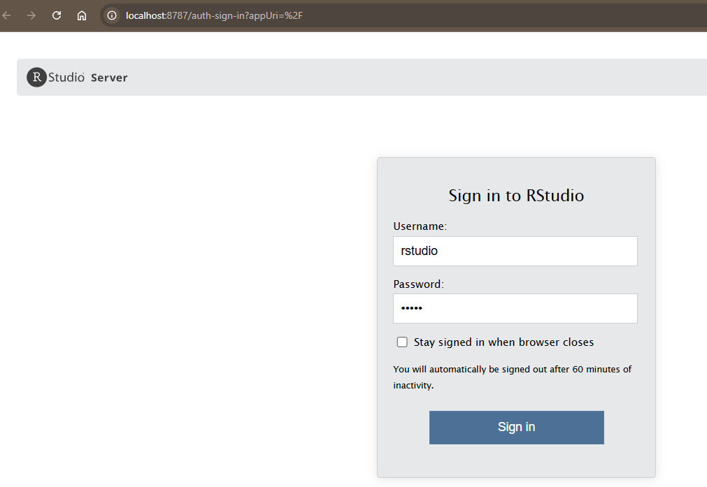
- Username: rstudio
- Password: data1
Your shared files should appear in RStudio under:
/home/rstudio/data
You should see something like this:
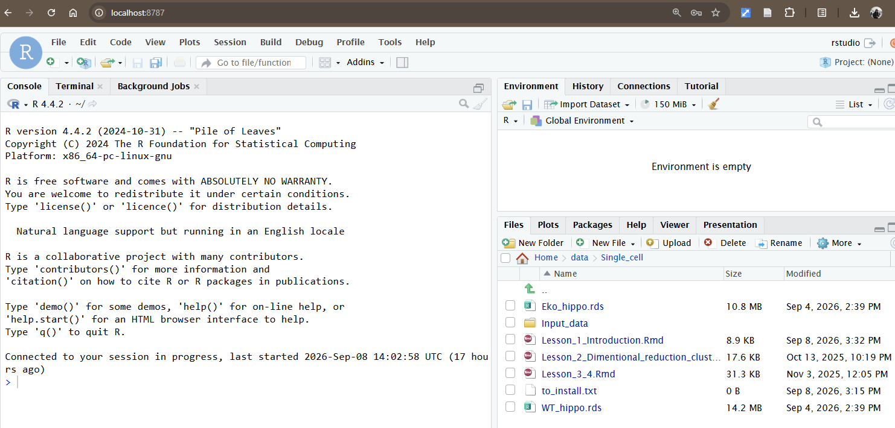

Useful container commands
Check whether the container is running:
docker ps
Stop the container:
docker stop seurat-rstudio
Restart it later without creating a new container:
docker start seurat-rstudio
Remove the container when it is no longer needed:
docker stop seurat-rstudio
docker rm seurat-rstudio
The image remains downloaded unless explicitly removed. To update to the latest version, first pull the image again, then remove and recreate the existing container using the relevant command above.
- https://docs.docker.com/engine/storage/bind-mounts/
- https://docs.docker.com/get-started/docker-concepts/running-containers/sharing-local-files/
- https://docs.docker.com/desktop/setup/install/windows-install/
- https://docs.docker.com/get-started/docker-concepts/running-containers/publishing-ports/
- https://docs.docker.com/engine/install/
- https://docs.docker.com/desktop/setup/install/linux/
- https://docs.docker.com/desktop/setup/install/mac-install/
- https://docs.docker.com/desktop/setup/install/mac-install.md
- https://github.com/docker/docker.github.io-1/blob/master/desktop/windows/index.md
- https://docs.docker.jp/desktop/mac/osxfs.html
- https://usedocker.com/install/mac
- https://github.com/vegasbrianc/docker.github.io/blob/master/docker-for-mac/osxfs.md
- https://learn.secbyte.org/tools/docker-desktop-security
- https://docs.docker.com/desktop/release-notes.md
- https://docs.docker.jp/v20.10/desktop/mac/index.html

